How to Diskpart Erase/Clean a Drive Through the Command Prompt

**Critical Instructions:**

* **Disclaimer: Seagate Technology, LLC is not responsible for lost user data. Be sure to back up any important data on this drive before proceeding.**
* **This article explains the Microsoft Diskpart Erase utility. The command that erases the drive during this process is "Clean". In this article "Clean" and erase are used interchangeably. Cleaning or erasing a storage device removes all data and partitions from the drive.**
* **Please read all steps, instructions, and warnings before attempting the Diskpart Erase/Clean.**
* **Diskpart Erase/Clean will permanently erase/destroy all data on the selected drive. Please make certain that you are erasing the correct disk.**
* **Remove all additional drives from the computer excluding the drive you are booting from and the drive you want to Erase/Clean.**

**Items to note:**

* This article will walk through the steps of using the Microsoft Diskpart Erase utility to Clean the disk of a previous partition and format, including any data on the drive. This command takes only a few minutes to complete.
* This article covers Diskpart Erasing a 3TB or larger drive that has a Master Boot Record (MBR) Partition table, which is thereby limiting its capacity to 2TB. However, this article also applies to any scenario where a Diskpart Erase of an entire disk is necessary.
* For more information regarding drives over 2TB and GPT/MBR partition tables please see the following articles.
  + [knowledge.seagate.com/articles/en_US/FAQ/218619en](http://knowledge.seagate.com/articles/en_US/FAQ/218619en)
  + <http://www.seagate.com/support/downloads/beyond-2tb/>

1. To determine the **disk number** assigned to the 3TB+ MBR partitioned drive follow the steps below.
   1. From the Start menu right *click* on Computer which will provide a drop down menu. (If you are on Windows 8 or 8.1 move your mouse to the bottom left hand corner of the desktop screen and right *click*. Then select **Disk Management**).
   2. Choose **Manage**.
   3. Select **Disk Management** (listed under Storage).
   4. Look for the drive that is identified as the 3TB drive (2794GB). The properties window shows that the partition table on the drive is MBR . **Important: note the Disk number (such as Disk 1).**   
      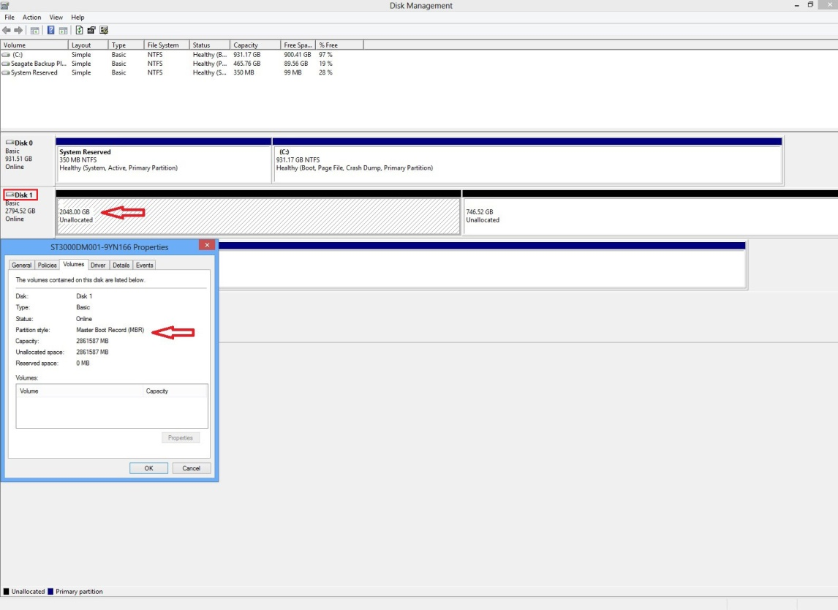
2. Open a Command Prompt window. To open the Command Prompt on a Windows Vista or Windows 7 machine *click* on Start and type **cmd** in the search bar. Then right *click* on **cmd.exe** and run as administrator. It will prompt you with the message, "Do you want to allow the following program to make changes to this computer," *click* **yes**. A black Command Prompt window will open.  
   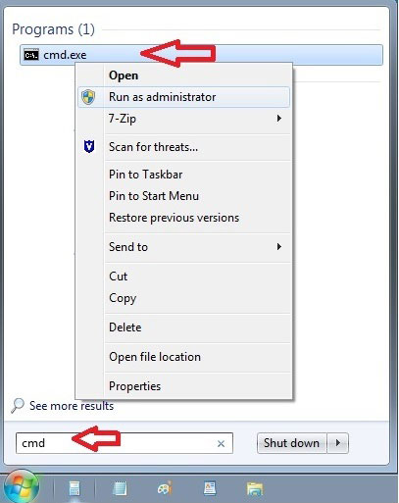  
     
   On Windows 8 move your mouse to the bottom left hand corner of the desktop screen and right click. Select **Command Prompt (Admin)** from the pop-up menu.  
   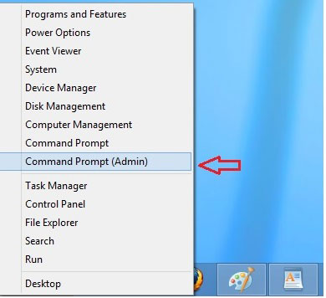  
     
   This is the Command Prompt window.  
   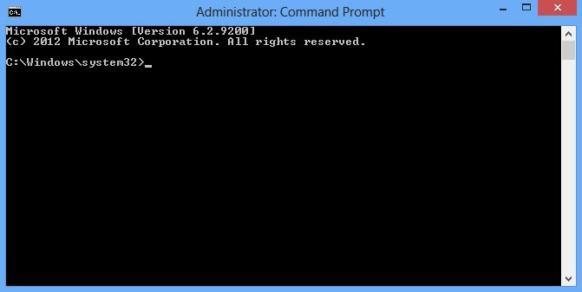
3. From the command prompt, type **diskpart** and press **Enter**.  
   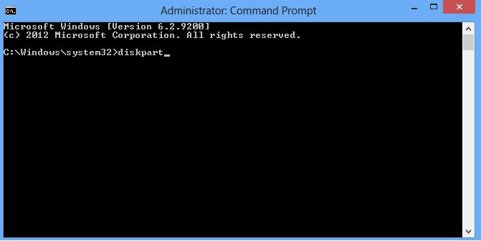  
     
   The diskpart prompt will open.  
   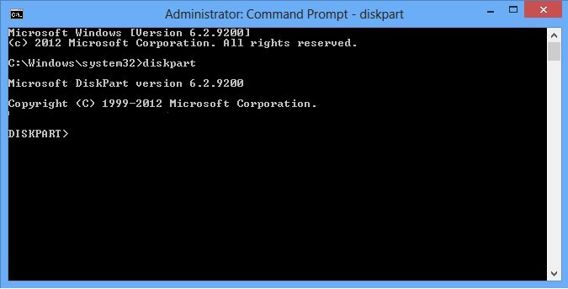
4. From the diskpart prompt, type **list disk** and press **Enter**.  
   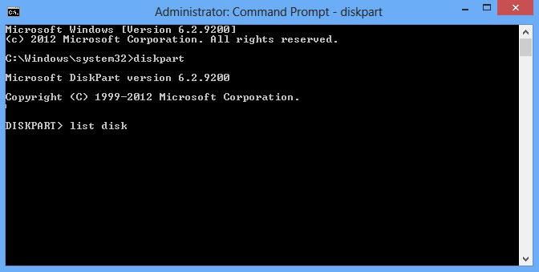  
     
   A list of disks will appear in a text format. You will return to the diskpart prompt. Step one verified that Disk 1 is the 3TB drive. **Warning: Diskpart Erase/Clean will permanently erase/destroy all data on the selected drive. Please be certain that you are erasing the correct disk.**   
     
   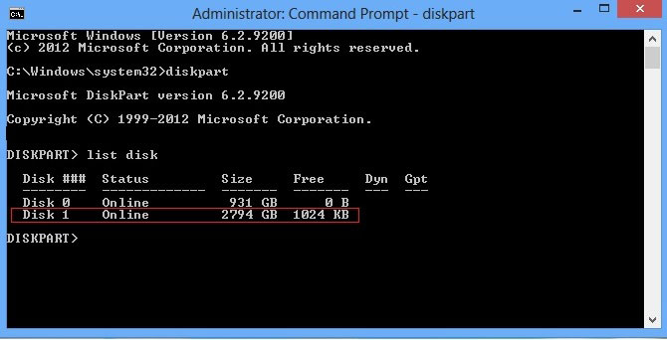
5. From the diskpart prompt you will need to **select a disk disk number** (for instance, if the 3TB+ drive is Disk 1, you would type **select disk 1**) and press **Enter**. **Warning: Diskpart Erase/Clean will permanently erase/destroy all data on the selected drive. Please be certain that you are erasing the correct disk.**   
   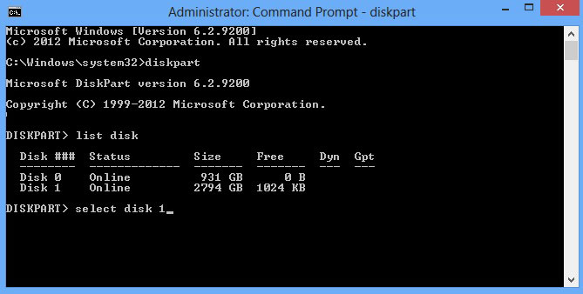  
     
   A message appears saying that the disk is selected. You will return to the diskpart prompt. **Warning: Diskpart Erase/Clean will permanently erase/destroy all data on the selected drive. Please be certain that you are erasing the correct disk.**   
   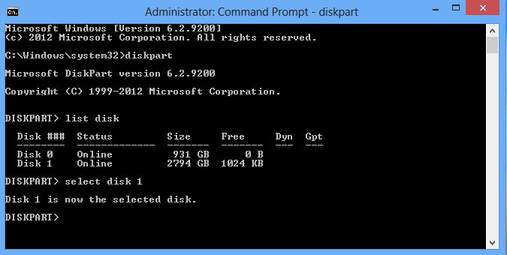
6. From the diskpart prompt, type **clean** and press **Enter**. The drive's partition, data, and signature is now removed. You will return to the diskpart prompt. **Warning: Once you type clean and hit enter the drive will be erased. No warning will be provided.**   
   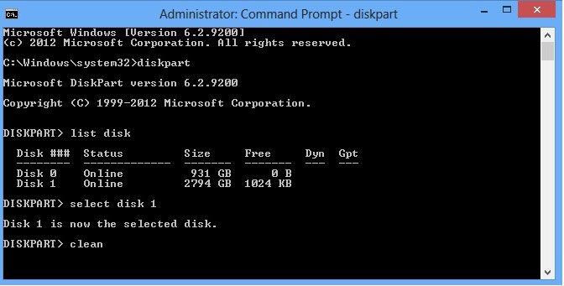
7. The Command Prompt window will display the message "**DiskPart succeeded in cleaning the disk**".  Close out of the Command Prompt window by *clicking* the **red X** in the upper right hand corner.  
   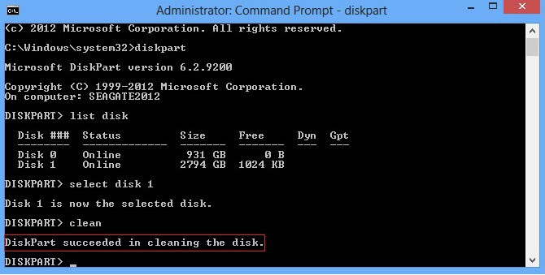  
     
   Now the 3TB+ drive can be re-initialized, partitioned, and formatted.